FlexiSpace Boardroom Booking System
Project Plan — Website & Mobile Application
Prepared by: [Team name / student numbers] · Course: INSY7315 · Date: [insert date]

1. Project overview
This plan covers the delivery of the FlexiSpace boardroom booking system: a centralised platform allowing staff and centre managers to book meeting rooms across Centurion, Houghton, and Eagle Canyon, with real-time synchronisation to Microsoft Outlook calendars. The client receives a website built to the original brief. In parallel, our team delivers a companion mobile application covering the core on-the-go booking features, built on the same backend.
Both the website and the mobile app are separate front ends that consume one shared backend API — neither app talks to the database directly, and neither app duplicates the other's business logic. This keeps the system consistent, secure, and maintainable.

2. System architecture
The diagram below shows how each component communicates. Arrows indicate the direction data flows.
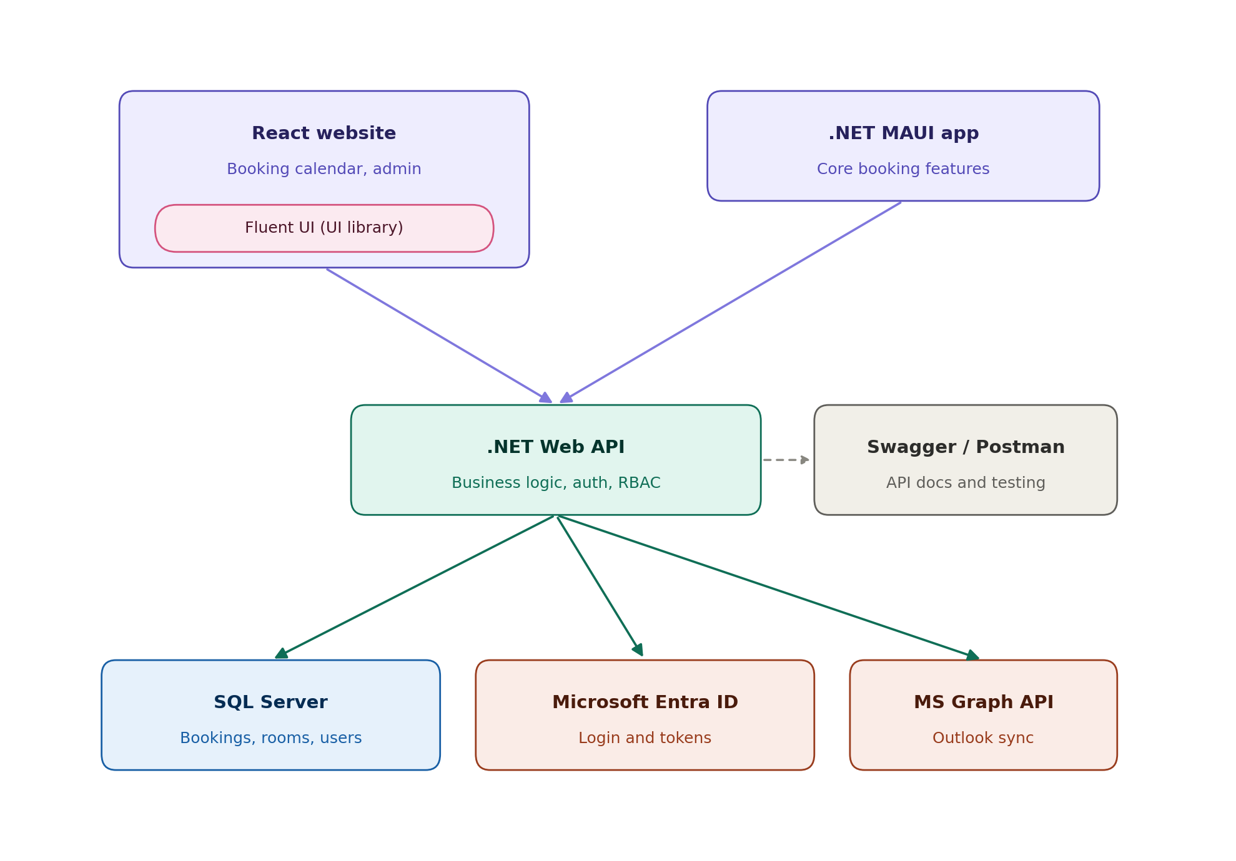
Note: the React website box includes Fluent UI, which is not a separate service — it is a component library imported directly into the website's code, used to visually match Microsoft 365 products (Outlook, Teams). Swagger and Postman are development tools, not part of live traffic — they document and test the API during build.

3. Technology stack, languages, and IDEs
Build order matters here — the database and API must exist before the website or mobile app can be built against real data.
Order | Component | Language | IDE | Notes
1 | Database schema | SQL / EF Core (C#) | Visual Studio | Modelled as C# classes; migrations generate the schema
2 | .NET Web API | C# | Visual Studio | Core business logic, auth, RBAC — everything else depends on this
3 | React website | JavaScript / JSX | VS Code | Consumes the API; uses Fluent UI component library
4 | .NET MAUI mobile app | C# / XAML | Visual Studio | Same IDE and language as the API and database

Hosting: Azure (backend, database, and website). Authentication: Microsoft Entra ID. Calendar sync: Microsoft Graph API.

4. Build order — step by step
- Step 1 — Whole team: agree the database schema and the API contract (endpoints, request/response shapes) in one working session. Write it down before any serious coding starts.
- Step 2 — Set up GitHub repo, branch protection, issue templates, and project board with milestones matching the phases in section 6.
- Step 3 — Set up Azure resource group and empty dev/staging environments.
- Step 4 — Backend: build EF Core models and run the first migration against the agreed schema.
- Step 5 — Backend: spike Entra ID login and a basic Microsoft Graph call in isolation, to prove the integration works before building on top of it.
- Step 6 — Backend: implement core booking CRUD, conflict detection, and role-based access control.
- Step 7 — In parallel with steps 4–6: website and mobile teams build their UI against the documented API contract, using mock data until real endpoints are ready.
- Step 8 — Connect website and mobile app to the real API as endpoints come online, replacing mock data.
- Step 9 — Add notifications, reporting/export, and the AI feature once core booking flows are stable.
- Step 10 — Testing pass across all three components, then deploy to Azure and package the mobile build.

5. How we are using GitHub
GitHub is our single source of truth for what's being worked on, so nobody depends on remembering verbal updates.
- GitHub Projects: one board with columns (To do / In progress / In review / Done), milestones matching each phase below.
- Issues: every task is an issue, assigned to a named person, tagged by component (backend / website / mobile / cross-cutting).
- Branching: one branch per issue (e.g. feature/booking-calendar), never committing directly to main.
- Pull requests: every branch is merged via a PR with at least one teammate's review — this also satisfies the WIL requirement for a genuine merged PR history.
- Commit messages: short, descriptive, tied to the issue number.
- .env.example committed from day one; real secrets never committed.
- README kept up to date with setup steps for all three components as they're built.

6. Phases and timeline
A fully-featured, production-quality booking system with Outlook sync, Entra ID auth, a mobile app, and an AI feature is not realistically finished in one to two weeks — the Entra ID and Microsoft Graph integration alone typically takes several days on its own. To stay honest with both our lecturer and the client, we are proposing two milestones: a working MVP in the first two weeks covering the core booking flow end to end, followed by the remaining features and polish over the following weeks of the project timeline.

Milestone 1 — MVP (target: end of week 2)
Phase | Deliverable | Target
Discovery & setup | Schema agreed, API contract documented, GitHub + Azure set up | Day 1–2
Backend core | Auth (Entra ID spike), basic booking CRUD, conflict detection | Day 3–7
Website core | Login, booking calendar (view + create), connected to real API | Day 5–10
Mobile core | Login, view availability, book/cancel a room | Day 5–10
MVP demo | End-to-end booking flow working across website, mobile, and Outlook | Day 12–14

Milestone 2 — Full system (remaining project weeks)
Phase | Deliverable
Roles & admin | Multi-role dashboards, admin user management, audit trail
Integrations | Full Graph webhook sync, notifications (email + in-app), AI feature
Reporting | Dashboard statistics, PDF/CSV export, reporting screens
Testing & docs | Unit tests, Postman collection, ER/UML diagrams, README, POPIA note
Deployment & handover | Azure deployment, mobile APK/IPA build, client sign-off, final demo

7. Security — built in from the start, not added later
We are treating security as part of every feature, not a separate task at the end, using the OWASP Top 10 (web/API) and OWASP Mobile Top 10 as our checklist.

Backend & API
- Role checks enforced server-side on every endpoint — never trusted from the front end alone.
- Passwords hashed with bcrypt/argon2 or ASP.NET Identity; never logged or stored in plain text.
- Parameterised queries / EF Core only — no raw string-concatenated SQL.
- Rate limiting and lockout on login, registration, and password reset.
- JWT tokens with expiry and refresh handling.
- No stack traces or raw database errors returned to clients.
- Audit log recording who did what and when on bookings and user records.

Mobile app
- Tokens stored in secure device storage (Keychain / Keystore), never plain text.
- No API keys or secrets hardcoded into the app bundle.
- HTTPS only for all API communication.

General
- All secrets in environment variables, never committed to Git.
- HTTPS enforced in deployment.
- POPIA awareness documented: what personal data is stored, why, and how it's protected.

8. Ways to distribute the work across 5 people
These are three possible structures, left unassigned so the team can decide together who takes what. Whichever structure is picked, everyone builds against the shared API contract agreed in step 1, so nobody is blocked waiting on someone else's finished code — and everyone should expect to contribute to testing and documentation for whatever they build, not leave it to one person at the end.

Option A — Balanced core + extra (recommended)
Each of the five slots carries one core build item plus one bounded extra responsibility, so nobody ends up with two heavy items while someone else has a light share.
Slot | Core ownership | Also owns | Assigned to
1 | Database, EF Core models, booking CRUD, conflict detection | ER diagram + migration docs
2 | Auth (Entra ID) + RBAC enforcement | Notifications system (email/in-app)
3 | Website — booking calendar, booking creation/edit flow | UML sequence diagram (booking flow)
4 | Website — admin dashboard, user management, reporting/export | README + POPIA/privacy note
5 | Mobile app (MAUI) — login, availability, book/cancel, notifications | Microsoft Graph integration (Outlook + Teams links)

Option B — By feature (vertical slices)
Each pair owns a feature end to end — database, API, and UI for that feature — rather than owning a layer across all features.
Slot | Owns | Assigned to
Pair 1 | Booking feature — schema, endpoints, and UI (website + mobile) for creating, viewing, and cancelling bookings
Pair 2 | Auth & admin feature — login, roles, user management, audit trail, across all three components
Solo | Integrations — Outlook sync, Teams links, notifications, reporting, AI feature

Option C — By layer
The traditional split — one layer per group, useful if the team prefers clean technical boundaries over shared feature ownership.
Slot | Owns | Assigned to
Pair 1 | All backend: database, API, auth, integrations — split by feature between the two
Pair 2 | Website: split screens between the two once the API contract is agreed
Solo | Mobile app, moving into testing and documentation support once mobile's core screens are done

9. Future enhancements worth adding
The client's original plan lists several future enhancements. Most (customer payments portal, CRM/billing integration, visitor management) are large builds not worth chasing on this timeline. Three, however, are cheap specifically because they reuse infrastructure the system already requires — not because they're inherently simple on their own.
Enhancement | Why it's easy for us | Effort
Microsoft Teams meeting links | Reuses the Microsoft Graph integration already being built for Outlook sync — Graph can attach a Teams join link to the same calendar event we're already creating | Low
QR code check-in | Needs no new backend concept — a QR code tied to an existing booking ID, plus one status-update endpoint similar to cancel/confirm which we're already building | Low
Catering request notifications | The client's booking data already includes a catering field; this reuses the same email notification pipeline built for booking confirmations, just a different trigger and recipient | Low

All three strengthen the submission with genuine extra features beyond the baseline checklist, without introducing new technical risk.

10. Things easy to forget — checklist
- AI feature — a real, working feature (e.g. suggesting the best available room/time), not decorative. Free-tier API only.
- Minimum two user roles with separate dashboards, not the same screen with hidden buttons.
- Soft delete / archiving on bookings, not permanent hard-delete only.
- Pagination, search, filtering, and sorting on all list views.
- ER diagram, architecture diagram, and UML class + sequence diagrams (login flow and one core booking flow).
- Unit tests covering core business logic (conflict detection especially).
- Client sign-off on the originally-scoped deliverable, kept as separate evidence from our enhanced submission.
- Regular feedback sessions with the client, keeping them updated against this plan.

11. Next check-in
We'll share progress against this plan at our next feedback session: [insert date]. Questions or scope changes on the client side should reach us before then so we can adjust the plan accordingly.

